Dataset
rnd_room_c2_04: HEAD tilt: -0.4
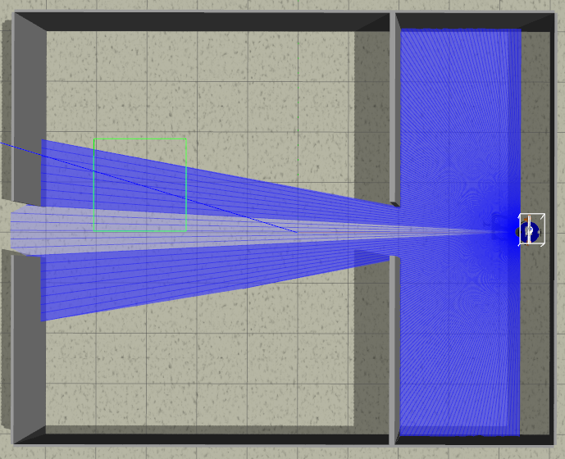
samples
1)
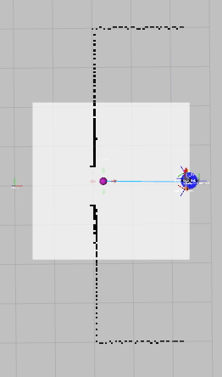
linea recta a puerta 2.3m (x2) (4.6 0.0 PI) to (2.2, 0.0)
files: data_from_path_2025-02-27_09-26-33 to data_from_path_2025-02-27_09-26-45

2)
inea recta a puerta 2.3m (x2) (4.6 0.0 0) to (2.2, 0.0)
files: data_from_path_2025-02-27_09-27-09 to data_from_path_2025-02-27_09-27-25

3)
inea recta a puerta 2.3m (x2) (4.6 0.0 1.57075) to (2.2, 0.0)
files: data_from_path_2025-02-27_09-28-15 to data_from_path_2025-02-27_09-28-27

4)
inea recta a puerta 2.3m (x2) (4.6 0.0 -1.57075) to (2.2, 0.0)
files: data_from_path_2025-02-27_09-29-19 to data_from_path_2025-02-27_09-29-33

5)
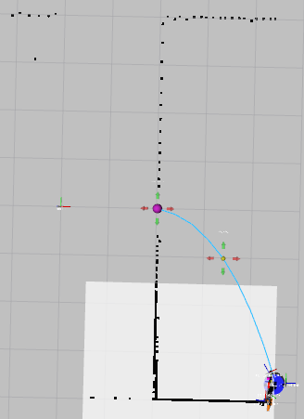
esq inf izq a puerta 4.4m (x2) (4.6 -3.6 PI) to (2.2, 0.0)
files: data_from_path_2025-02-27_09-33-19 to data_from_path_2025-02-27_09-33-36

6)
esq inf izq a puerta 4.4m (x2) (4.6 -3.6 0) to (2.2, 0.0)
files: data_from_path_2025-02-27_09-34-04 to data_from_path_2025-02-27_09-34-21

7)
esq inf izq a puerta 4.4m (x2) (4.6 -3.6 1.57075) to (2.2, 0.0)
files: data_from_path_2025-02-27_09-34-59 to data_from_path_2025-02-27_09-35-14

8)
esq inf izq a puerta 4.4m (x2) (4.6 -3.6 -1.57075) to (2.2, 0.0)
files: data_from_path_2025-02-27_09-35-44 to data_from_path_2025-02-27_09-36-01

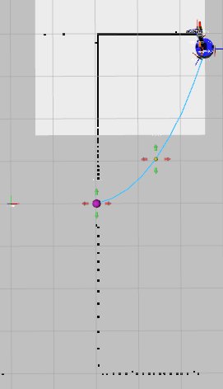
9)
esq inf der a puerta 4.4m (x2) (4.6 3.6 PI) to (2.2, 0.0)
files: data_from_path_2025-02-27_09-40-01 to data_from_path_2025-02-27_09-40-18

10)
esq inf der a puerta 4.4m (x2) (4.6 3.6 0) to (2.2, 0.0)
files: data_from_path_2025-02-27_09-40-53 to data_from_path_2025-02-27_09-41-16

11)
esq inf der a puerta 4.4m (x2) (4.6 3.6 1.57075) to (2.2, 0.0)
files: data_from_path_2025-02-27_09-41-50 to data_from_path_2025-02-27_09-42-43

12)
esq inf der a puerta 4.4m (x2) (4.6 3.6 -1.57075) to (2.2, 0.0)
files: data_from_path_2025-02-27_09-43-16 to data_from_path_2025-02-27_09-43-33

13)
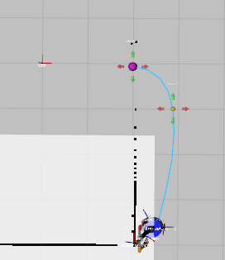
esq sup izq a puerta 3.5m (x2) (2.5 -3.6 PI) to (2.2, 0.0)
files: data_from_path_2025-02-27_09-50-49 to data_from_path_2025-02-27_09-51-11

14)
esq sup izq a puerta 3.5m (x2) (2.5 -3.6 0) to (2.2, 0.0)
files: data_from_path_2025-02-27_09-51-39 to data_from_path_2025-02-27_09-51-55

15)
esq sup izq a puerta 3.5m (x2) (2.5 -3.6 1.57075) to (2.2, 0.0)
files: data_from_path_2025-02-27_09-52-36 to data_from_path_2025-02-27_09-52-52

16)
esq sup izq a puerta 3.5m (x2) (2.5 -3.6 -1.57075) to (2.2, 0.0)
files: data_from_path_2025-02-27_09-53-20 to data_from_path_2025-02-27_09-53-37

17)
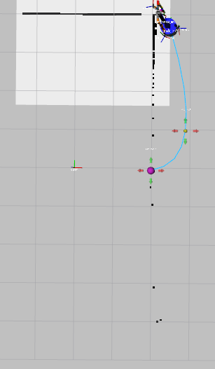
esq sup der a puerta 3.7m (x2) (2.5 3.6 PI) to (2.2, 0.0)
files: data_from_path_2025-02-27_09-56-44 to data_from_path_2025-02-27_09-57-01

18)
esq sup der a puerta 3.7m (x2) (2.5 3.6 0) to (2.2, 0.0)
files: data_from_path_2025-02-27_09-57-34 to data_from_path_2025-02-27_09-58-07

19)
esq sup der a puerta 3.7m (x2) (2.5 3.6 1.57075) to (2.2, 0.0)
files: data_from_path_2025-02-27_09-58-39 to data_from_path_2025-02-27_09-58-57

20)
esq sup der a puerta 3.7m (x2) (2.5 3.6 -1.57075) to (2.2, 0.0)
files: data_from_path_2025-02-27_09-59-28 to data_from_path_2025-02-27_09-59-46

21)
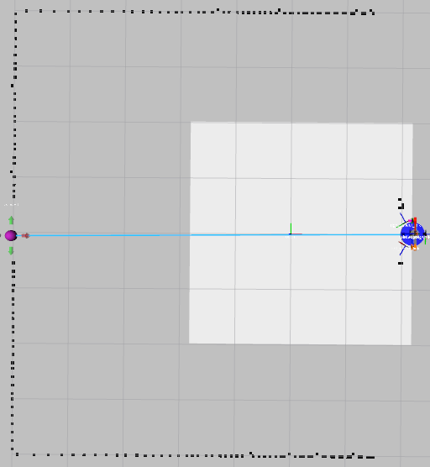
puerta a puerta 7.2m (x3) (2.2 0.0 PI) to (2.758, -3.502)
files: data_from_path_2025-02-27_10-03-38 to data_from_path_2025-02-27_10-03-38

22)
puerta a puerta 7.2m (x3) (2.2 0.0 0) to (2.758, -3.502)
files: data_from_path_2025-02-27_10-06-12 to data_from_path_2025-02-27_10-06-57

-----
NO Mirror
-----

